fitflex: your personal fitness companion

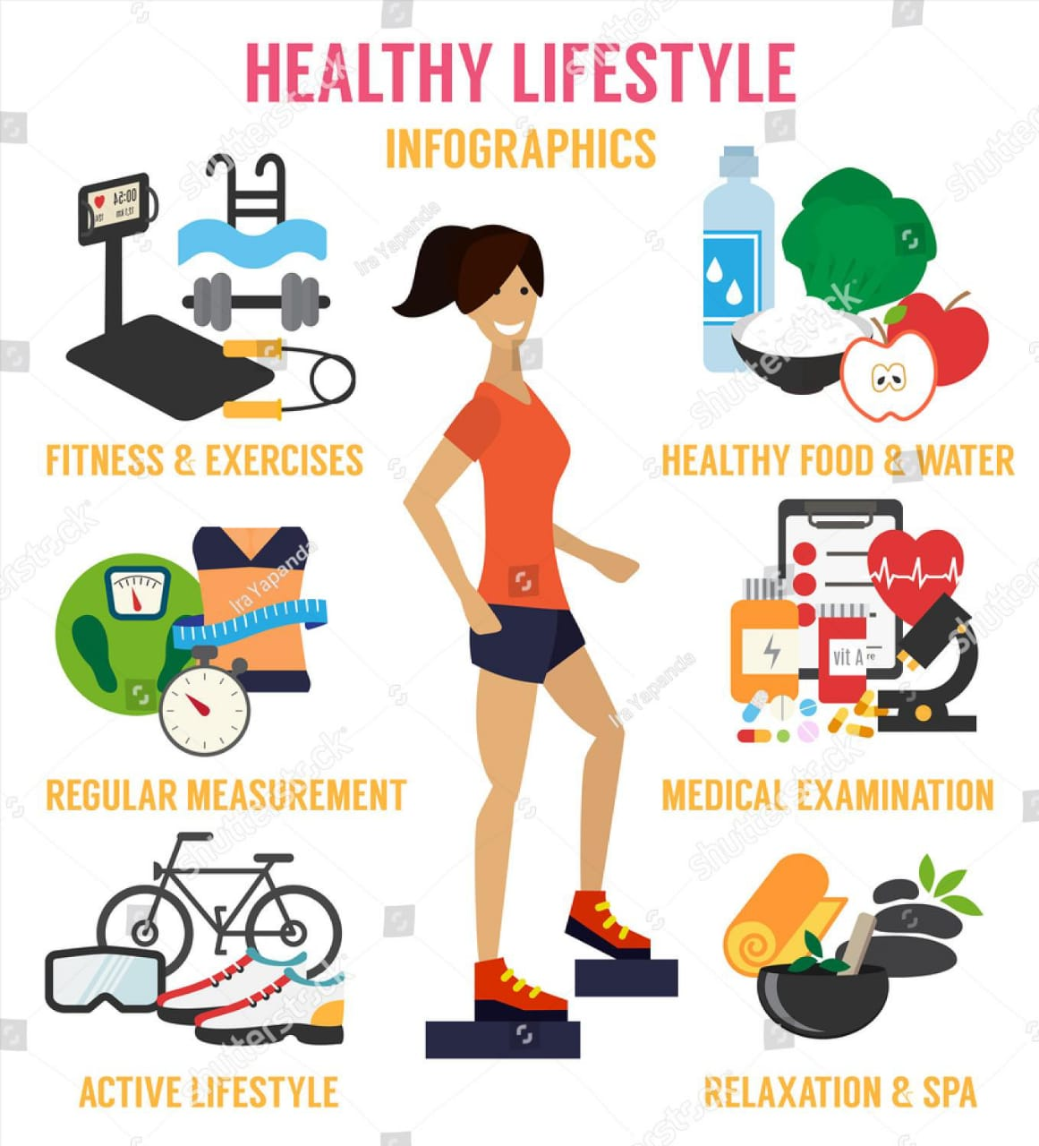

Title: Fitflex your personal fitness companion

**My Name: Gobika.SM**

**My team members are:**

👉**Abinaya.R**

👉**Arundhathi.P**

👉**Avanthika**

👉**Aswini.S**

**Institution Name:**

**VALLIAMMAL COLLEGE FOR WOMEN**

**Date:05/09/2025**

**1.Introduction:**

**Fitflex is a health and fitness application designed to encourage individuals to adopt a healthy lifestyle.**

**2.Problem Statement:**

👉**Lack of time and motivation to maintain regular fitness.**

👉**Absence of personalized workouts and diet recommendations.**

👉**Difficulty in tracking fitness progress setting achievable goals.**

**3.Objectives of the project:**

**1.To create a user-friendly platform for fitness and wellness.**

**2.To provide personalized workout and diet recommendations.**

**3.To increase awareness about mental health, meditation and stress management.**

**4.Features of FITFLEX:**

♦**️User profile & goals: Customize fitness level,weight goals, and dietary preferences.**

♦**️Diet & Nutrition:**

**Personalized meal suggestion with calorie counts.**

**5.Advantages of Fit flex:**

👉**Affordable alternative to personal trainers.**

👉**All-in-one fitness and wellness solution.**

👉**Accessible anytime, anywhere.**

👉**Encourage long-term healthy habits.**

## 6.Future scope:

👉 Integratio with wearable devices.

👉coporate wellness program.

👉virtual reality fitness session.

## 7.conclusion

Fitflex is not just a fitness app; it is a complete wellness companion .By combining technology , fitness and lifestyle management.The project aims to provide healthier living among individuals.Fitflex has a potential to become a leading fitness platform .

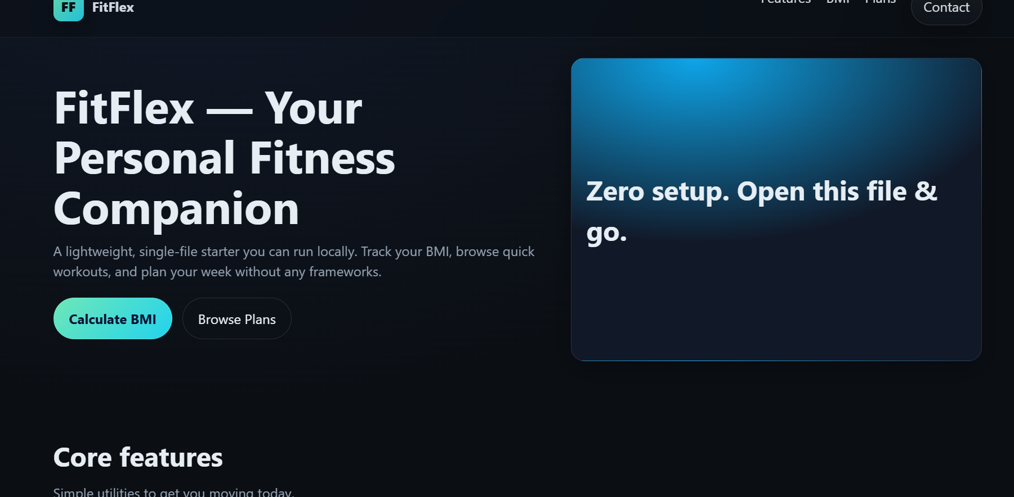



**Thank you for this opportunity.**

|  |  |  |
| --- | --- | --- |
|  |  |  |
|  |  |  |